Course Code: CPL801 | Course Name: Cloud Computing Laboratory
Class :TECO | Batch :2
Roll no :15CO10 | Name :ANSARI SAEEM

Experiment : 03

Aim : Study & Installation of Owncloud.

Theory:
Explain Storage as a Service.
Storage as a service (SaaS) is a business model in which a company leases or rents its storage infrastructure to another company or individuals to store data. Small companies and individuals often find this to be a convenient methodology for managing backups, and providing cost savings in personnel, hardware and physical space.
A company providing SaaS may be called a storage service provider (SSP). Storage as a service can also be referred to as hosted storage.

Explain EU GDPR.
General Data Protection Regulation (GDPR) is the new European Union privacy law, approved in 2016 jointly by European Parliament, the Council of the European Union and the European Commission.
GDPR will replace the existing European Data Protection Directive (which btw, came into the picture in 1995), which will be in effect until May 25, 2018. Post this date, GDPR will supersede and all the laws attached to data protection will be governed by GDPR.
GDPR aims to bring all the EU member states under one umbrella by enforcing a single data protection law. GDPR is intended to put guidelines and regulations on how data is processed, used, stored or exchanged.
There are three major stakeholders under these regulations, namely:
- Data controllers decide the purposes and methods of processing personal data — they coordinate processing.
- Data processors are responsible for directly processing personal data based on the instructions of data controllers. This could, for example, include subcontractors.
- Data subjects are the citizens of EU using goods and services provided by the data controllers.

Explain the features of Owncloud
Features of Owncloud
1)Fileshare
2)Syncing
3)External Storage
4)Encryption and Security
5)Storage API
6)Flexible API
7)federated Cloud Sharing
8)Guests
9)password Policy
10)End To End Encryption

Explain any 2 alternatives of Owncloud.

1) Seafile
As one of the most prominent ownCloud Alternatives, Seafile is a favorite amongst users who particularly value Open Source. Seen in many ways as a type of Dropbox clone, both the server and the client are based on an open source code. Seafile also supports the option of end-to-end client encryption.
Installing the software is relatively easily and in terms of functions it certainly matches up to ownCloud. All the same, with Seafile the focus is primarily on file sharing and collaboration. This means that unlike ownCloud, there is no overall solution for all cloud requirements. This means there are several functions not offered, e.g. synchronization services like CardDav or CalDav.
This particular host offers a good range of services when it comes to file administration and user collaboration; both a commenting and messaging function, as well as file versioning, are the aspects of Seafile making it particularly attractive for team projects. A high level of reliability and speedy synchronization add to the appealing nature of the program. Seafile is available for macOs, Windows, and Linux users, as well as for iOS and Android. The server can be run over Windows, Linux or a Raspberry Pi.

2) Nextcloud
Nextcloud is the self-proclaimed evolution of ownCloud. Several former ownCloud developers have come together with the aim of further developing the program that they had originally helped develop. The familiar structure of the software makes for an easy transition for users from ownCloud to Nextcloud. The team is currently working to further improve cloud saving services. According to a recent report, Nextcloud are currently focusing on inclusion of the user community, with the hope of implementing features that the users themselves want to see.
Screen Shot:
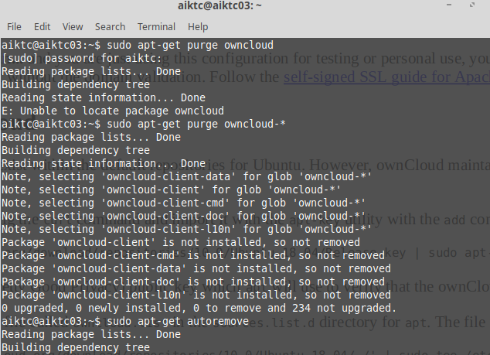

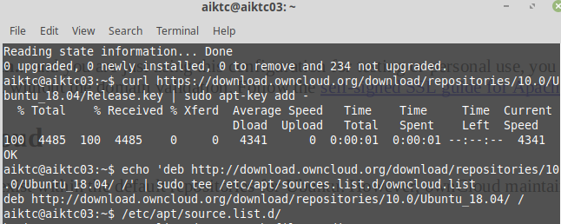

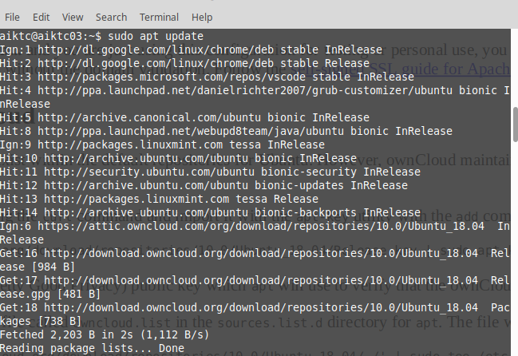

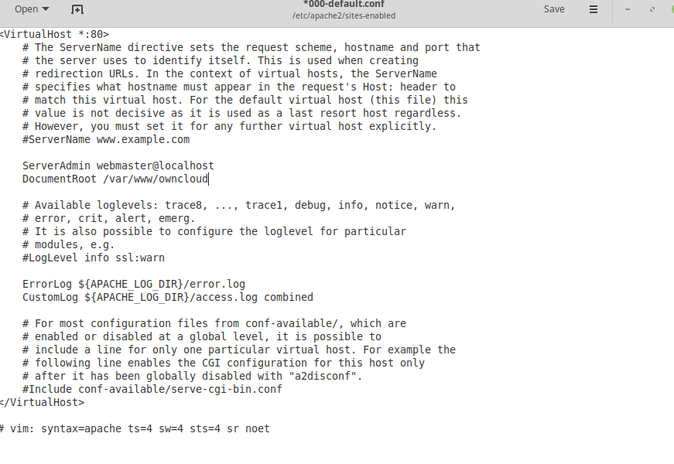

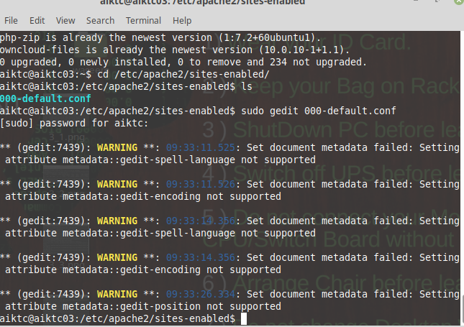

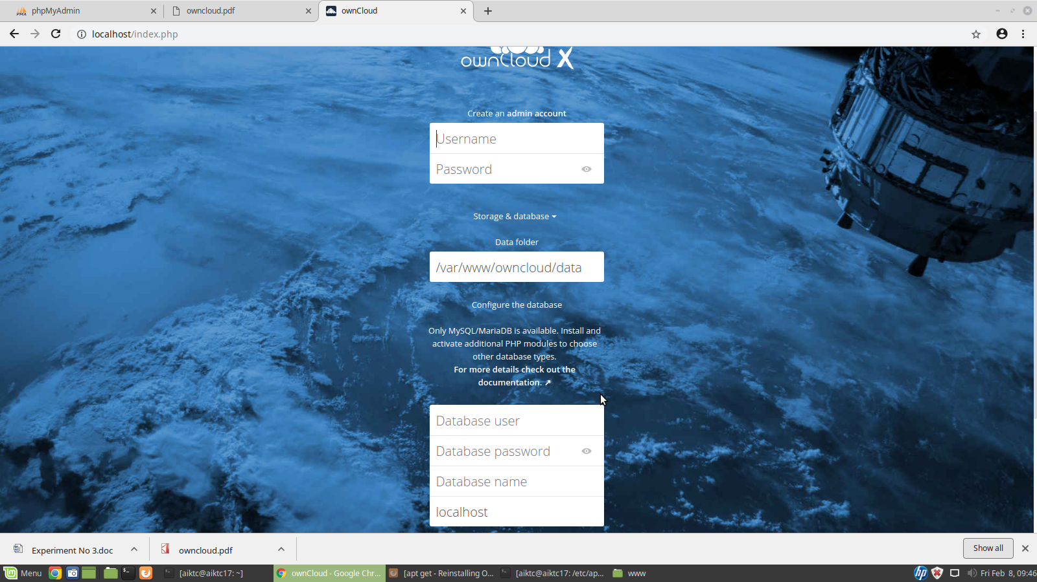

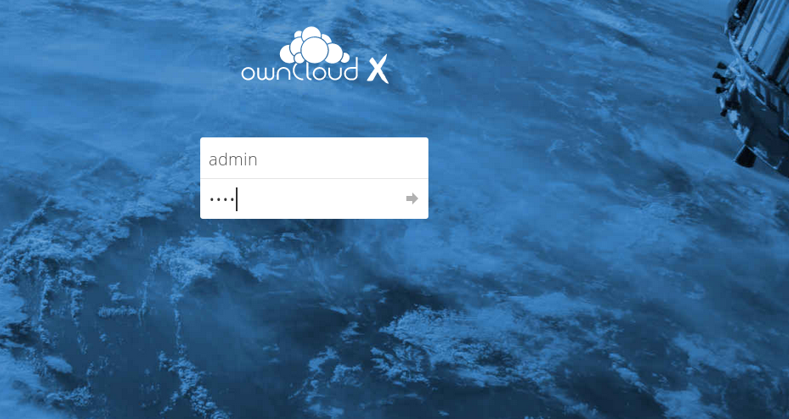

Reference:
https://www.digitalocean.com/community/tutorials/how-to-install-and-configure-owncloud-on-ubuntu-18-04
https://owncloud.org/
Conclusion: In this experinment we learn installation of owncloud Nextcloud is the self-proclaimed evolution of ownCloud. Several former ownCloud developers have come together with the aim of further developing the program that they had originally helped develop.

